- Bluebook Page43 August 2019 Variant Five examination:

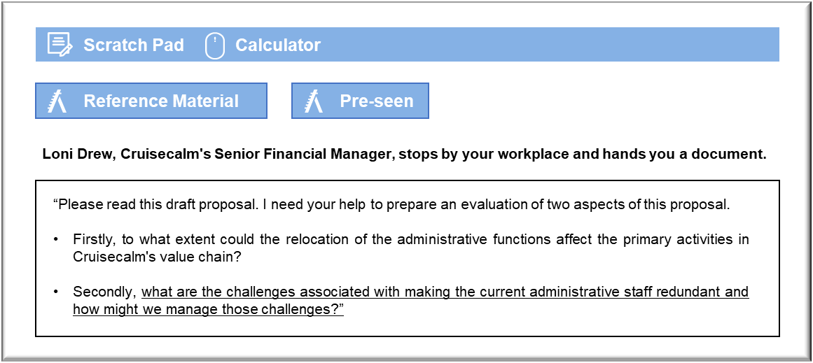

MANAGEMENT CASE STUDY AUGUST 2019 EXAM ANSWERS

Variant5 Task1
These answers have been provided by CIMA for information purposes only. The answers created are indicative of a response that could be given by a good candidate. They are not to be considered exhaustive, and other appropriate relevant responses would receive credit.

CIMA will not accept challenges to these answers on the basis of academic judgement.

Requirement 1: Relocation
The primary activities in Cruisecalm’s value chain relate to the creation of added value through the provision of a service. It could be argued that the relocation will have little impact on inbound logistics because purchases of fuel, food and other materials associated with running the ship are purchased locally by ships’ crews in any case. Ships will take delivery of their orders in the various ports of call and so very little is likely to change, provided the new administrative arrangements do not affect payments to suppliers, which could disrupt services if ships cannot collect.
Operations involves the actual provision of cruises. At first glance, it could be argued that the
relocation will have very little impact on cruises because the ships are located overseas and
operate remotely in any case. There will be no need to replace crew members or recruit
differently. The biggest concern could be the relocation of shipyard liaison, which ensures that major repairs and modifications are carried out properly. It will be a similar story with maintenance work. Each ship is expected to spend two weeks in dry dock every few years and it will be imperative that all work is completed on time or departures will be delayed. This aspect of support is a fundamental element of operations and so it is possible to reduce costs by relocation.
Outbound logistics involves ensuring that customers receive the service that they have
purchased. The relocation could affect matters because Cruisecalm must be aware of any
difficulties associated with flights, which will depart from Norland, do not disrupt passengers’ travel arrangements. It may be that the relocation will make it more difficult for Cruisecalm to monitor flights and to ensure that the impacts of delays and cancellations are understood.Marketing and sales can be divided between the direct sales that are made through Cruisecalm’s website and those that are made through travel agents in Norland. In principle, online sales can
be organised from anywhere and the company’s website can be maintained from anywhere that has an internet connection. Problems could arise in maintaining contact with travel agents in Norland, who may be less inclined to promote Cruisecalm’s holidays if they start to lose contact with the company.
Finally, service could be a problem because passengers may require advice before travelling
and may wish to offer feedback or make complaints after their return. If contact is made via a call centre that set up in a foreign country then potential passengers may be put off and returning passengers may decide not to rebook.
These answers have been provided by CIMA for information purposes only. The answers
created are indicative of a response that could be given by a good candidate. They are
not to be considered exhaustive, and other appropriate relevant responses would
receive credit.
CIMA will not accept challenges to these answers on the basis of academic judgement.
August 2019 2 Management Case Study Exam

Requirement 2: Redundancy
Staff will start to look for new jobs once the redundancy notice has been issued, which could
disrupt administrative operations in the short term. The departure of staff members, before they have handed over properly to the replacement team, could lead to errors and might disrupt operations. The staff will also be demotivated, because their briefings will be to enable their replacements to take their jobs from them.
Ships crews could also start to fear that Cruisecalm will replace them with foreign workers who can do their jobs more cheaply. In the short term, that could prove demotivating, with passengers noticing a reduced quality of service because of this. There is even a possibility that crew members in key deck or engineering roles will resign and disrupt sailings, because their presence is required for operational and/or safety reasons before the ship can go to sea.
The disruption during the handover might be best dealt with by offering attractive redundancy terms that will only be granted if staff members remain in post until a designated date. If Cruisecalm augments the statutory redundancy payments, then staff may feel that the company has done something to address the inconvenience associated with losing their jobs. The payments may also reduce the pressure to obtain a new job immediately and make staff less desperate to take the first job that is offered to them.
Effective communication is important, otherwise problems could arise because staff may be
unsettled by unfounded fears that they could be made redundant. Cruisecalm should send a very clear signal to ships’ crews that the redundancies are due to the potential savings associated with moving the administrative functions overseas. The signal has to be clear and credible, but should not create ill feeling amongst the staff who are losing their jobs in Norland. It may be sufficient to prepare a clear statement that will go to every member of staff that announces the redundancy package in very clear terms, but stresses that the changes will be restricted to those employed in the administrative offices in Norland.

